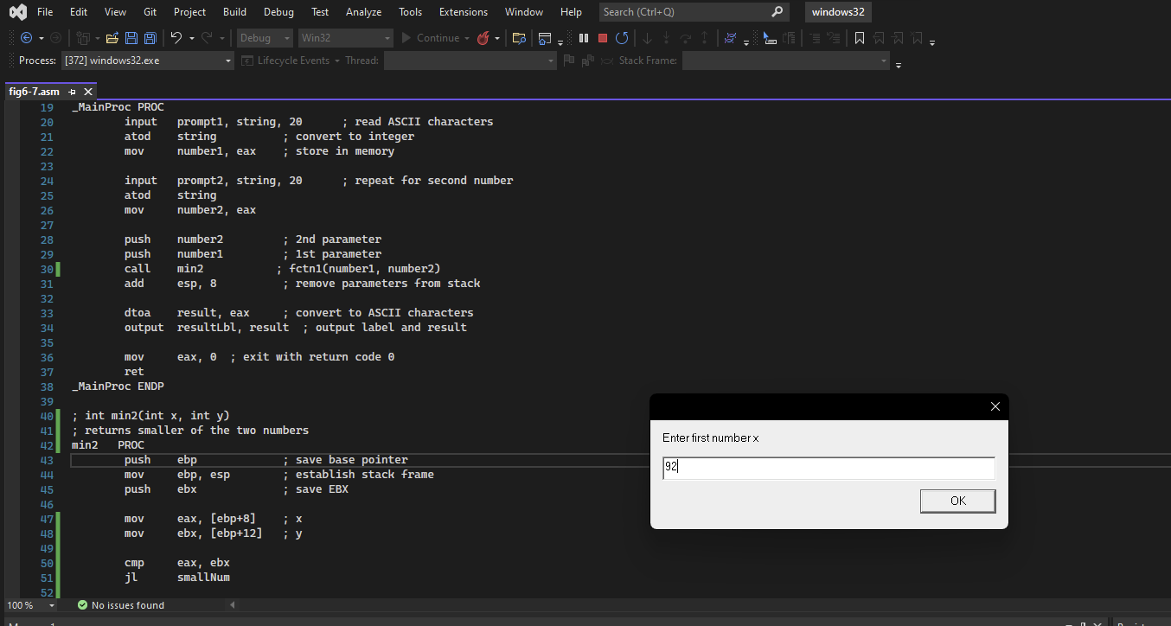

My T# is T00289254, so the first number 92.

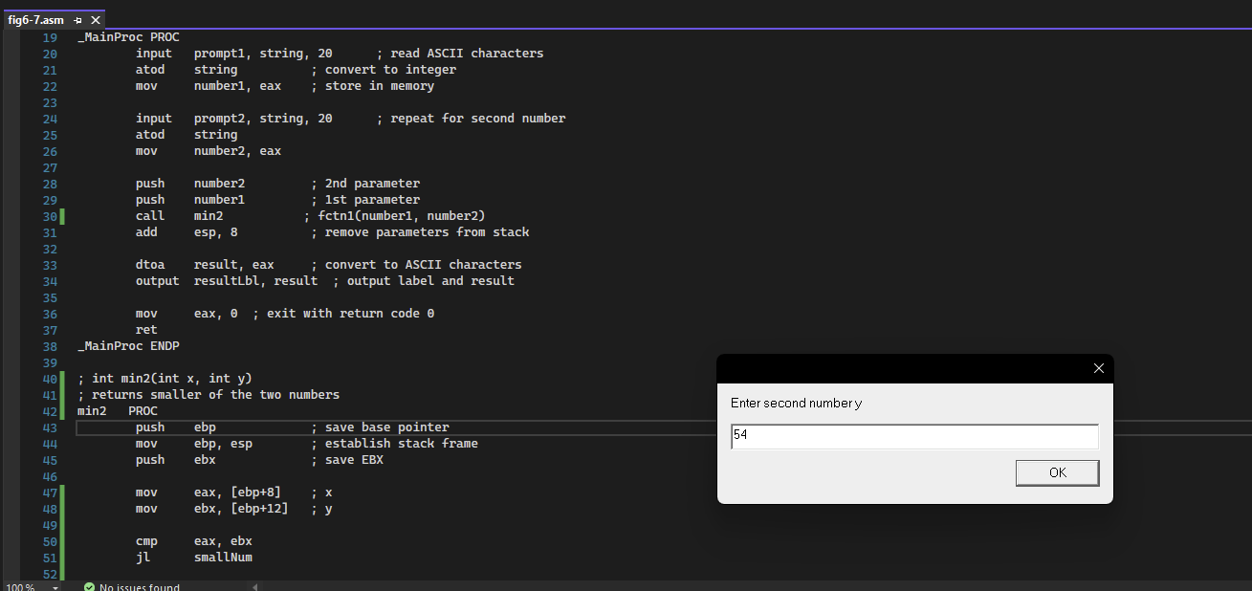

Second number is 54

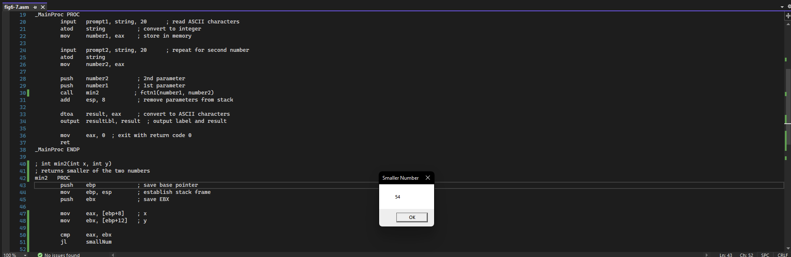

Finally it prints the smaller of the two numbers that is 54.